**JOIN**

USE master;

-- =============================================

-- Database: JOINExample

-- =============================================

IF EXISTS

(

SELECT *

FROM sys.databases

WHERE name = N'JOINExample'

)

DROP DATABASE JOINExample

GO

CREATE DATABASE JOINExample;

GO

-- =============================================

-- Database: JOINExample

-- Table: Persons

-- =============================================

USE JOINExample;

GO

IF EXISTS

(

SELECT name

FROM sys.tables

WHERE name = 'Persons')

DROP TABLE Persons

GO

CREATE TABLE Persons

(

PersonID int NOT NULL,

FirstName varchar(20),

LastName varchar(20),

GenderID int

);

GO

INSERT

Persons

(

PersonID,

FirstName,

LastName,

GenderID

)

VALUES

(

1,

'Gertrude',

'Larson',

1

)

INSERT Persons

(

PersonID,

FirstName,

LastName

)

VALUES

(

2,

'Raymond',

'Kouma'

)

INSERT

Persons

(

PersonID,

FirstName,

LastName,

GenderID

)

VALUES

(

3,

'Peter',

'Mukuko',

2

)

INSERT

Persons

(

PersonID,

FirstName,

LastName,

GenderID

)

VALUES

(

4,

'Wally',

'Baston',

2

)

INSERT

Persons

(

PersonID,

FirstName,

LastName

)

VALUES

(

5,

'Sylvia',

'Nguyen'

)

INSERT

Persons

(

PersonID,

FirstName,

LastName,

GenderID

)

VALUES

(

6,

'Donald',

'Wallace',

2

)

INSERT

Persons

(

PersonID,

FirstName,

LastName,

GenderID

)

VALUES

(

7,

'Hermine',

'Kana',

1

)

INSERT

Persons

(

PersonID,

FirstName,

LastName

)

VALUES

(

8,

'Charlotte',

'Thomas'

)

INSERT

Persons

(

PersonID,

FirstName,

LastName

)

VALUES

(

9,

'Paula',

'Barbers'

)

INSERT

Persons

(

PersonID,

FirstName,

LastName,

GenderID

)

VALUES

(

10,

'Chrissie',

'Dentd',

3

)

GO

SELECT * FROM Persons

-- =============================================

-- Database: JOINExample

-- Table: Genders

-- =============================================

USE JOINExample;

GO

IF EXISTS

(

SELECT name

FROM sys.tables

WHERE name = 'Genders')

DROP TABLE Genders

GO

CREATE TABLE Genders

(

GenderID int,

Gender varchar(20)

);

GO

INSERT

Genders

(

GenderID,

Gender

)

VALUES

(

1,

'Female'

)

INSERT

Genders

(

GenderID,

Gender

)

VALUES

(

2,

'Male'

)

INSERT

Genders

(

GenderID,

Gender

)

VALUES

(

3,

'Unknown'

)

GO

INSERT

Genders

(

GenderID

)

VALUES

(

4

)

GO

INSERT

Genders

(

Gender

)

VALUES

(

'Undefined'

)

GO

SELECT * FROM Genders

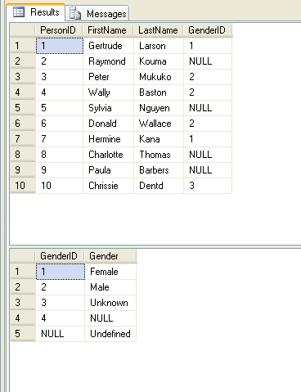

-- =============================================

-- Database: JOINExample

-- Table: Employees

-- =============================================

USE JOINExample;

GO

IF EXISTS

(

SELECT name

FROM sys.tables

WHERE name = 'Employees')

DROP TABLE Employees

GO

CREATE TABLE Employees

(

EmployeeID int NOT NULL,

EmployeeName varchar(20),

EmployeeManagerID int

);

GO

INSERT

Employees

(

EmployeeID,

EmployeeName

)

VALUES

(

1,

'Bill Gates'

)

INSERT

Employees

(

EmployeeID,

EmployeeName,

EmployeeManagerID

)

VALUES

(

2,

'Sergey Brin',

1

)

INSERT

Employees

(

EmployeeID,

EmployeeName,

EmployeeManagerID

)

VALUES

(

3,

'Steve Ballmer',

2

)

INSERT

Employees

(

EmployeeID,

EmployeeName,

EmployeeManagerID

)

VALUES

(

4,

'Larry Page',

3

)

INSERT

Employees

(

EmployeeID,

EmployeeName,

EmployeeManagerID

)

VALUES

(

5,

'Anders Hejlsberg',

4

)

GO

SELECT * FROM Employees

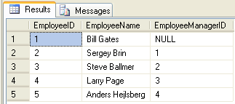

**Types of Join:**

**Inner Join**

* **Self Join**
* **Natural Join**
* **Equi Join**

**Outer Join**

* **Left Outer Join**
* **Right Outer Join**
* **Full Outer Join**

**Cross Join**

**(INNER) JOIN**

* **SELF JOIN**

SELECT E1.EmployeeName 'Manager', E2.EmployeeName 'Employee'

FROM Employees E1 JOIN Employees E2

ON E1.EmployeeID = E2.EmployeeManagerID

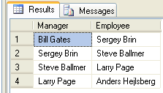

* **Natural Join**

SELECT Persons.*, Genders.Gender

FROM

Persons

JOIN

Genders

ON Persons.GenderID = Genders.GenderID

SELECT P.*, G.Gender

FROM

Persons P

JOIN

Genders G

ON P.GenderID = G.GenderID

SELECT P.PersonID, P.FirstName, P.LastName, P.GenderID, G.Gender

FROM

Persons P

JOIN

Genders G

ON P.GenderID = G.GenderID

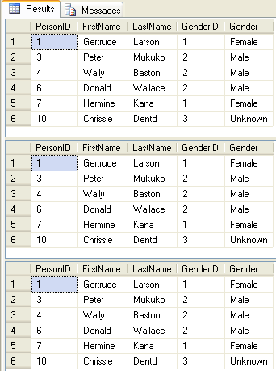

* **Equi Join**

SELECT *

FROM

Persons

JOIN

Genders

ON Persons.GenderID = Genders.GenderID

SELECT *

FROM

Persons

INNER JOIN

Genders

ON Persons.GenderID = Genders.GenderID

SELECT *

FROM

Persons P

INNER JOIN

Genders G

ON P.GenderID = G.GenderID

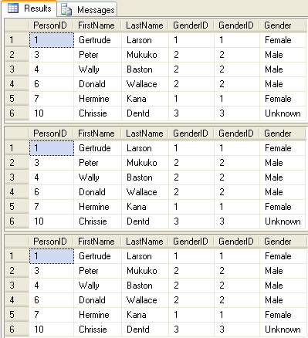

SELECT *

FROM

Genders

JOIN

Persons

ON Persons.GenderID = Genders.GenderID

SELECT *

FROM

Genders

INNER JOIN

Persons

ON Persons.GenderID = Genders.GenderID

SELECT *

FROM

Genders G

INNER JOIN

Persons P

ON P.GenderID = G.GenderID

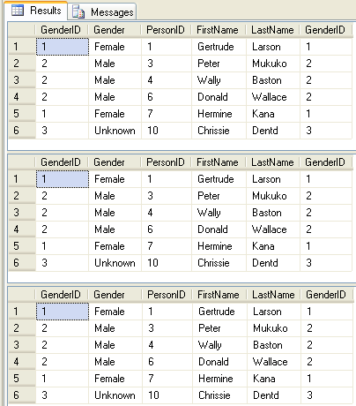

**OUTER JOIN**

* **LEFT OUTER JOIN**

SELECT *

FROM

Persons

LEFT OUTER JOIN

Genders

ON Persons.GenderID = Genders.GenderID

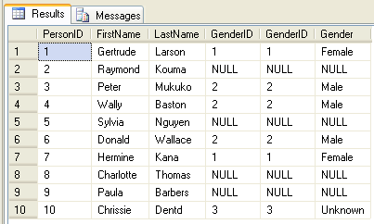

* **RIGHT OUTER JOIN**

SELECT *

FROM

Genders

RIGHT OUTER JOIN

Persons

ON Persons.GenderID = Genders.GenderID

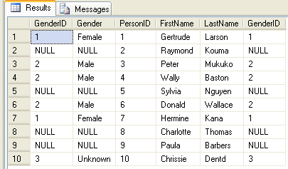

* **LEFT OUTER JOIN**

SELECT *

FROM

Genders

LEFT OUTER JOIN

Persons

ON Persons.GenderID = Genders.GenderID

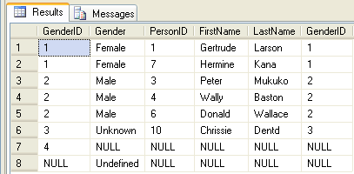

* **RIGHT OUTER JOIN**

SELECT *

FROM

Persons

RIGHT OUTER JOIN

Genders

ON Persons.GenderID = Genders.GenderID

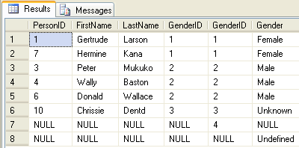

* **FULL OUTER JOIN**

SELECT *

FROM

Persons

FULL OUTER JOIN

Genders

ON Persons.GenderID = Genders.GenderID

SELECT *

FROM

Genders

FULL OUTER JOIN

Persons

ON Persons.GenderID = Genders.GenderID

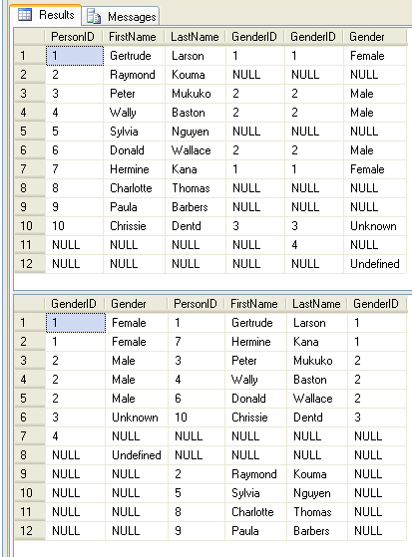

**CROSS JOIN**

SELECT *

FROM

Persons

CROSS JOIN

Genders

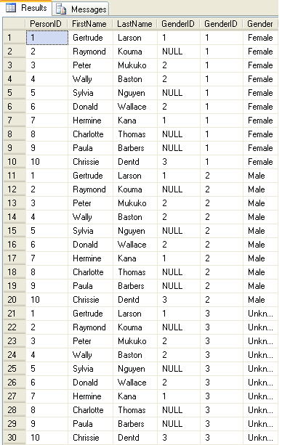

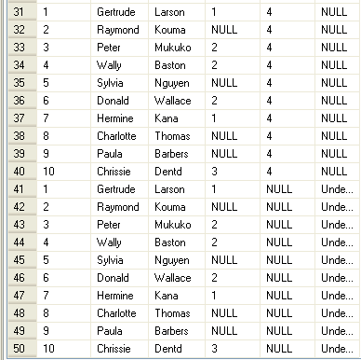

SELECT *

FROM

Genders

CROSS JOIN

Persons

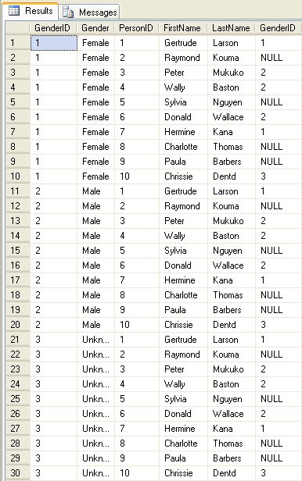

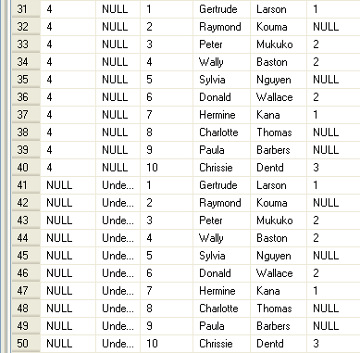

SELECT *

FROM

Persons

CROSS JOIN

Genders

WHERE Persons.GenderID = Genders.GenderID

SELECT *

FROM

Genders

CROSS JOIN

Persons

WHERE Persons.GenderID = Genders.GenderID

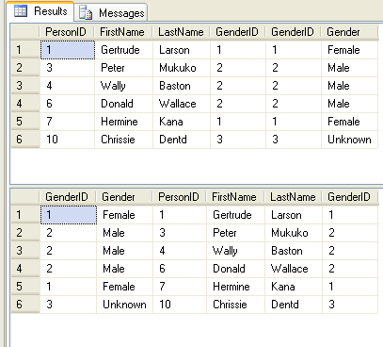

References:

<http://functionx.com/sqlserver/Lesson15.htm>

<http://programming.top54u.com/post/Types-of-Joins-in-Sql-Server-2005.aspx>